Lab Exercise 8– Terraform Multiple tfvars Files
Objective:
Learn how to use multiple tfvars files in Terraform for different environments.
Prerequisites:
- Terraform installed on your machine.
- Basic knowledge of Terraform configuration and variables.
Steps:
- Create a Terraform Directory:

mkdir terraform-multiple-tfvars
cd terraform-multiple-tfvars
- Create Terraform Configuration Files:
- Create a file named main.tf:
# main.tf
provider "aws" {
region = var.region
}

resource "aws_instance" "example" {
ami = var.ami
instance_type = var.instance_type
}
- Create a file named variables.tf:
# variables.tf
variable "ami" {
type = string
}

variable "instance_ty" {
type = string
}

Output:-
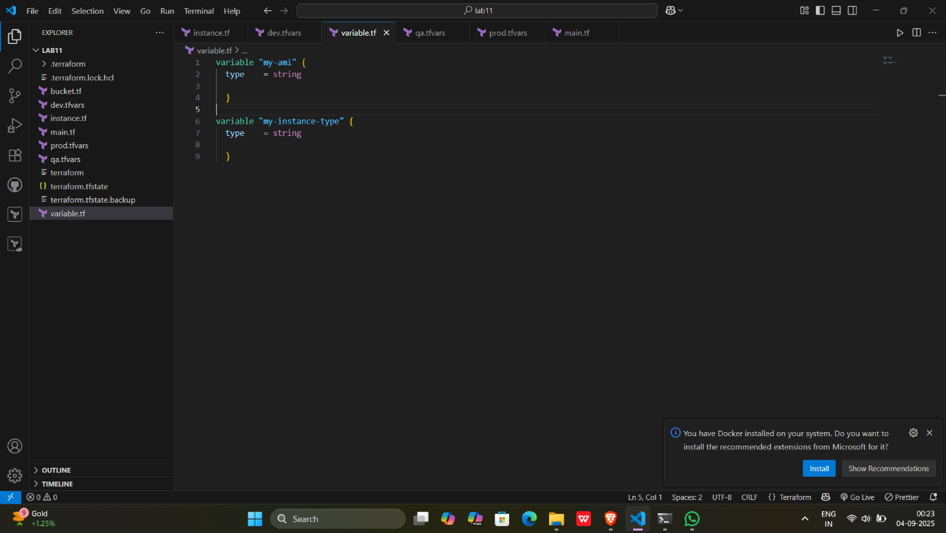
- Create Multiple tfvars Files:
- Create a file named dev.tfvars:
# dev.tfvars
ami = "ami-0123456789abcdef0"
instance_type = "t2.micro"
- Create a file named prod.tfvars:

Output:-
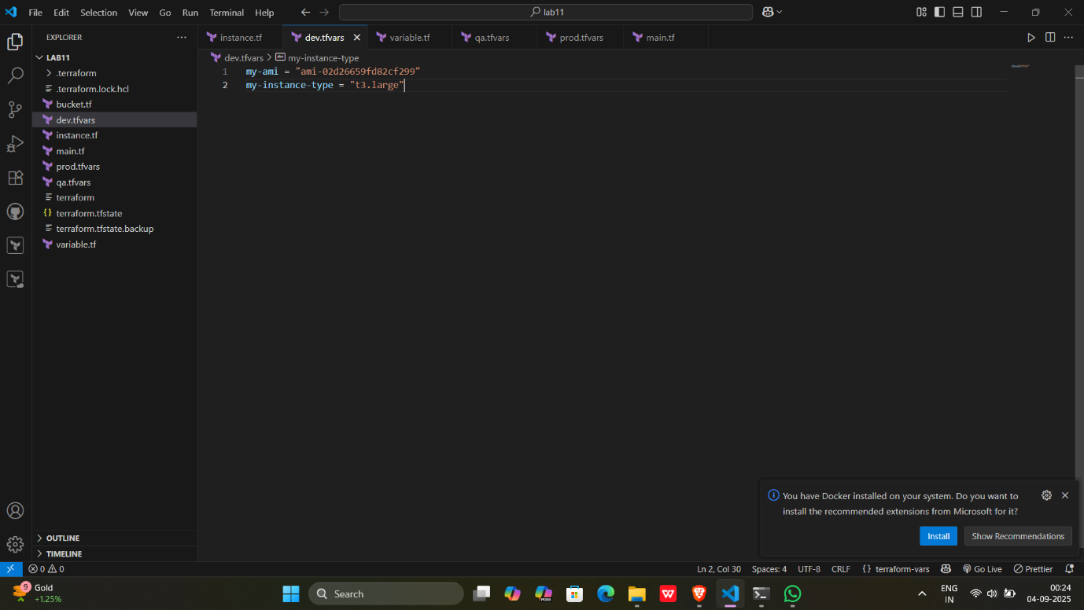
#qa.tfvars
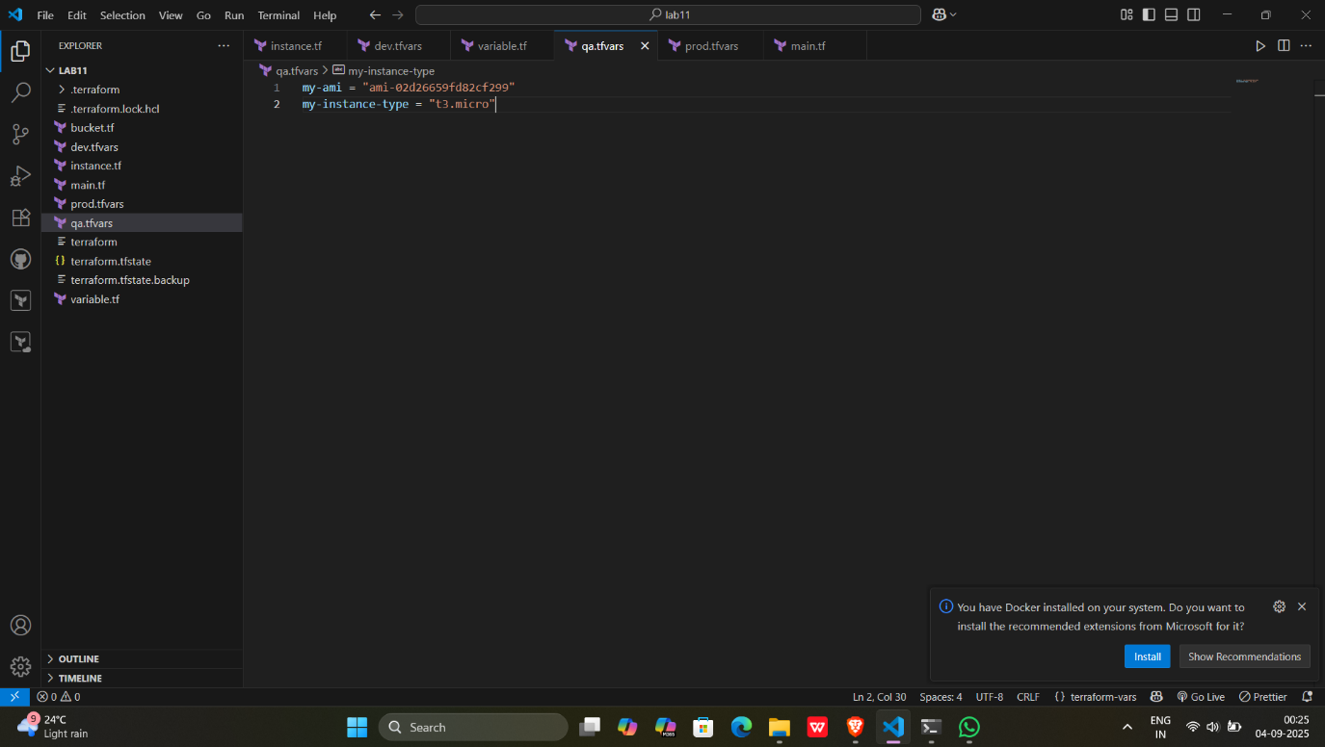
# prod.tfvars
ami = "ami-9876543210fedcba0"
instance_type = "t2.large"
- In these files, provide values for the variables based on the environments.

Output:-

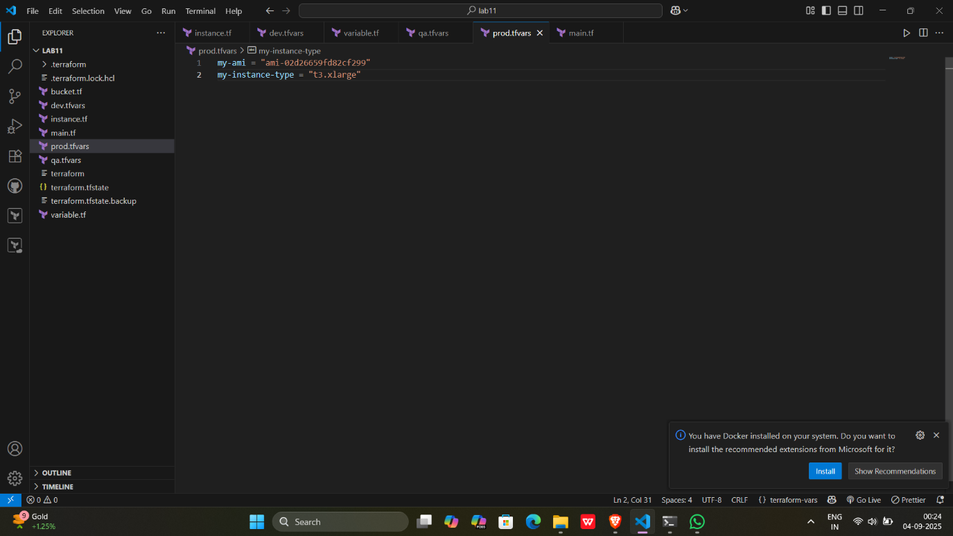

- Initialize and Apply for Dev Environment:
- Run the following Terraform commands to initialize and apply the configuration for the dev environment:
terraform init
terraform apply -var-file=dev.tfvars

Output:-
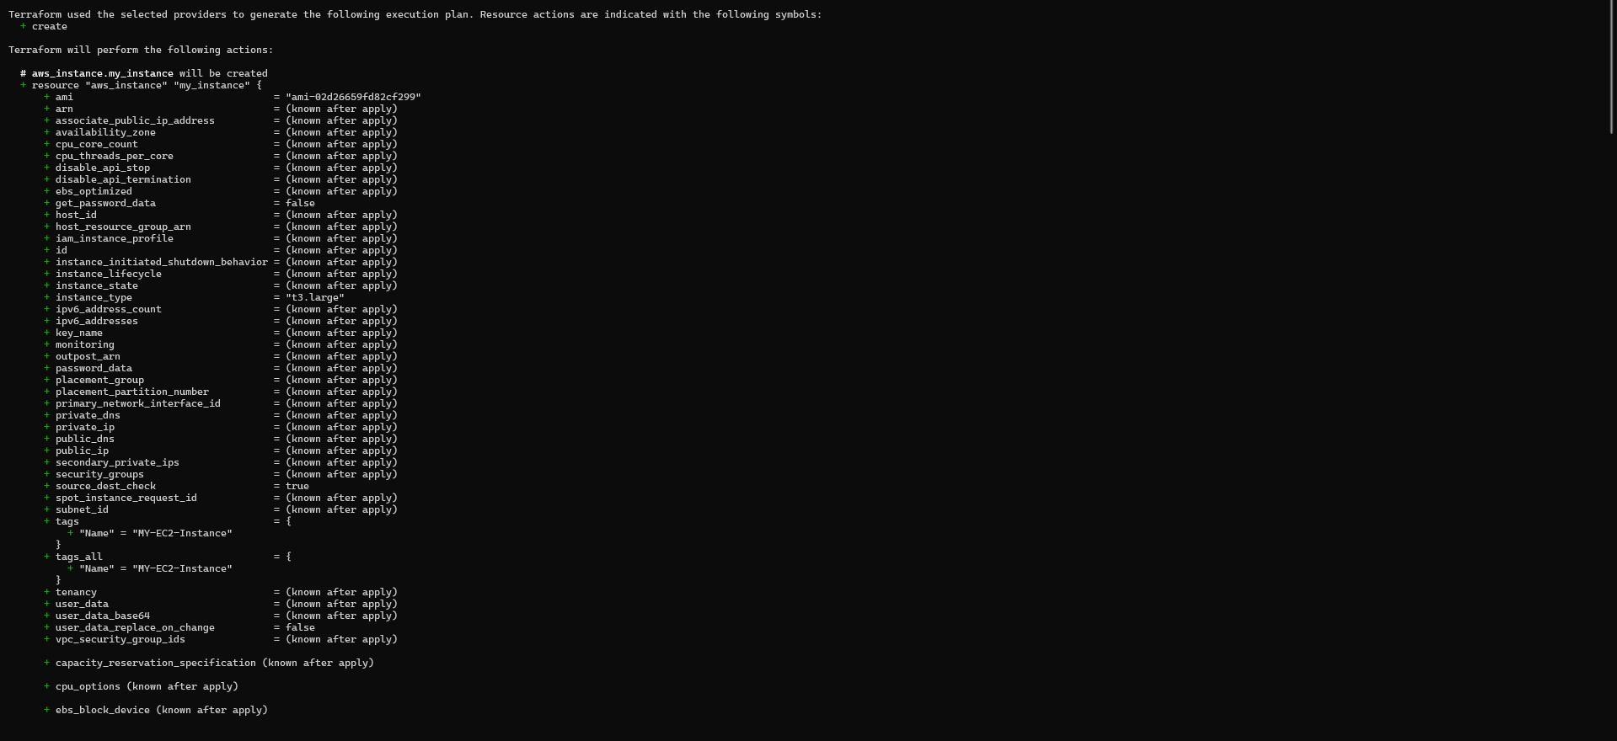
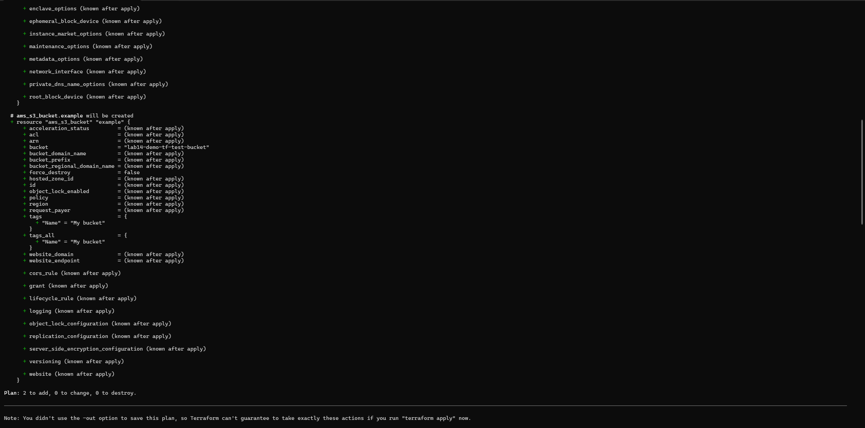
- Initialize and Apply for Qa Environment:
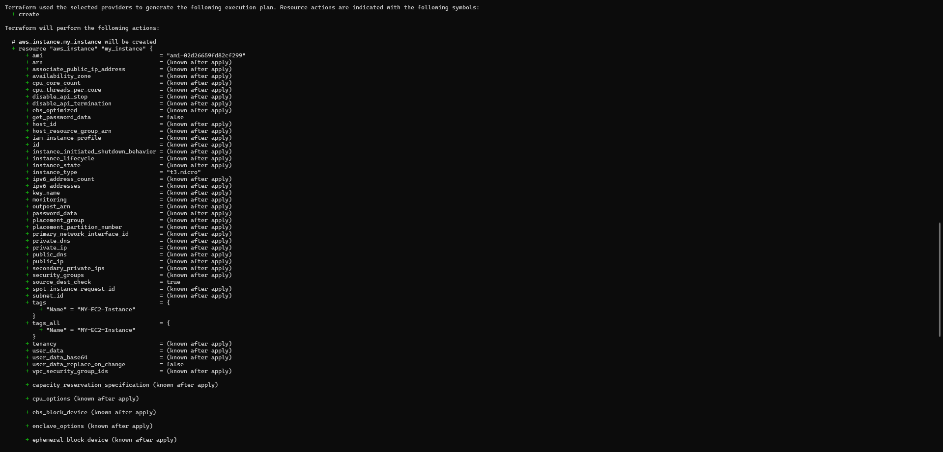

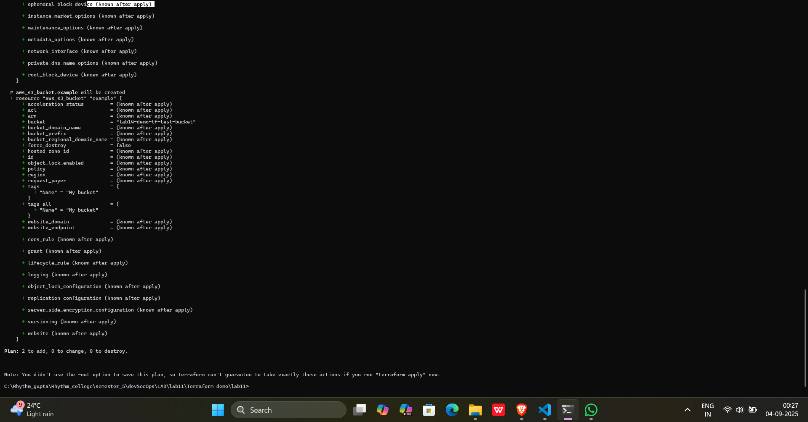
Terraform apply command for qa environment
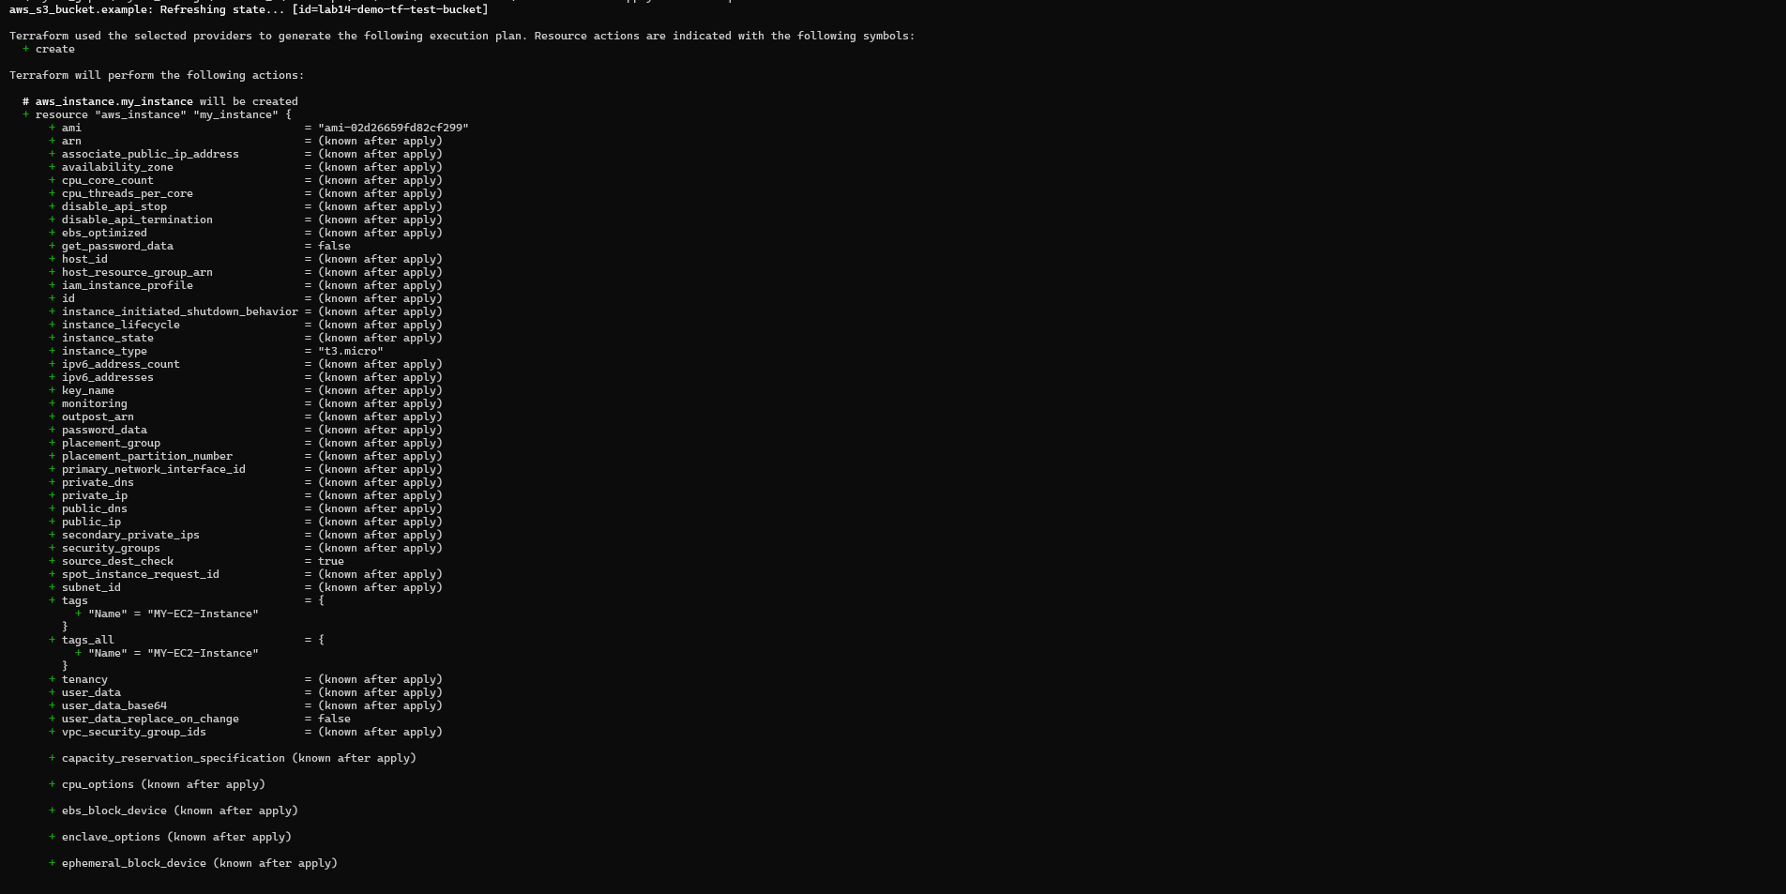
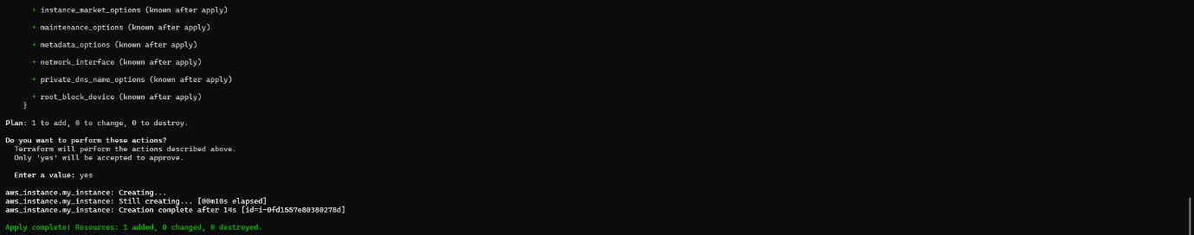

- Initialize and Apply for Prod Environment:
- Run the following Terraform commands to initialize and apply the configuration for the prod environment:
terraform init
terraform apply -var-file=prod.tfvars

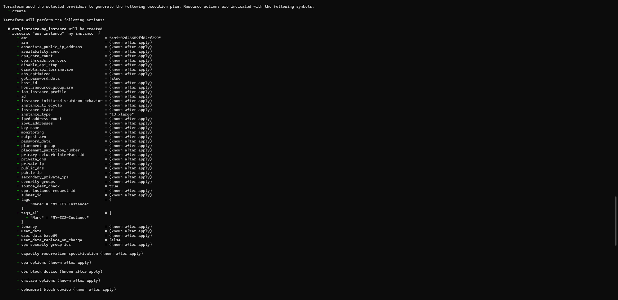
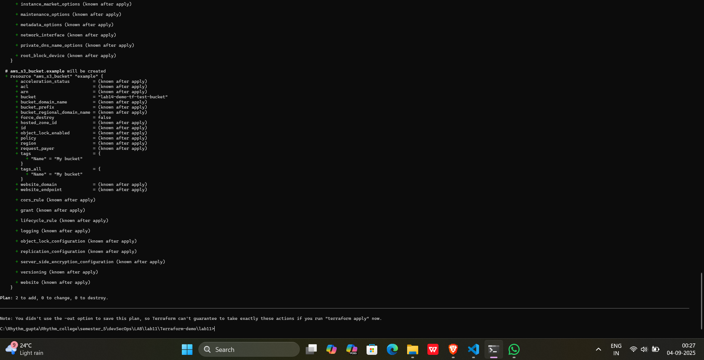
- Test and Verify:
- Observe how different tfvars files are used to set variable values for different environments during the apply process.
- Access the AWS Management Console or use the AWS CLI to verify the creation of resources in the specified regions and instance types.
- Clean Up:
- After testing, you can clean up resources:
terraform destroy -var-file=dev.tfvars
terraform destroy -var-file=prod.tfvars
- Confirm the destruction by typing yes.

Output:-
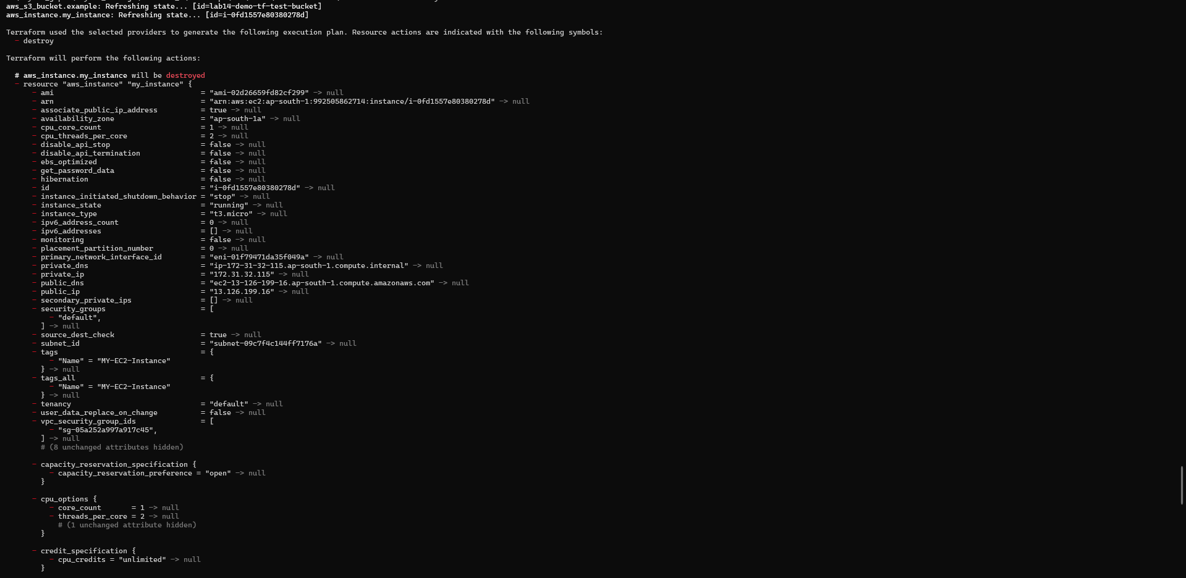
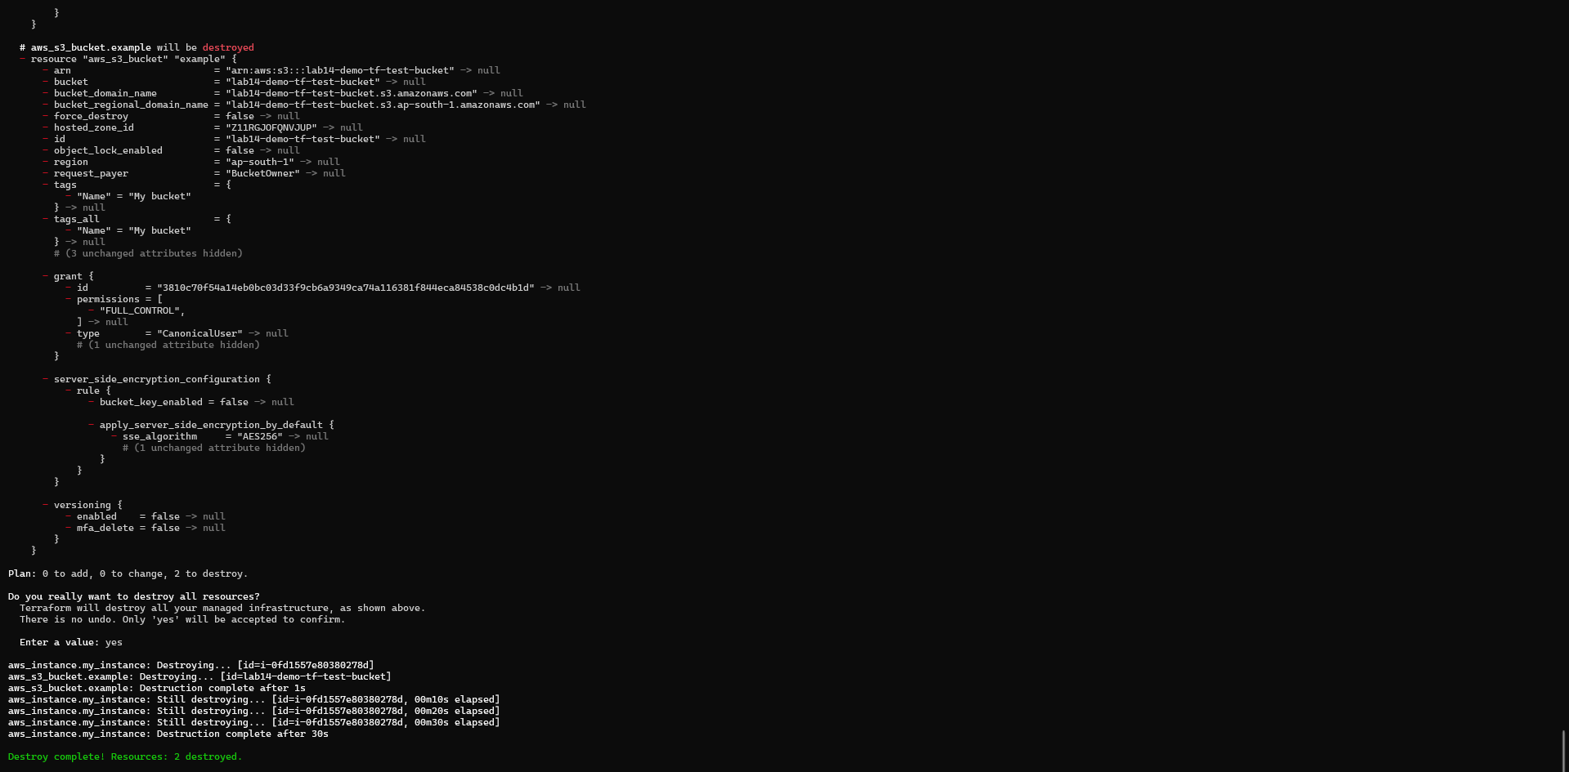

- Conclusion:
This lab exercise demonstrates how to use multiple tfvars files in Terraform to manage variable values for different environments. It allows you to maintain separate configuration files for different environments, making it easier to manage and maintain your infrastructure code. Experiment with different values in the dev.tfvars and prod.tfvars files to observe how they impact the infrastructure provisioning process for each environment.

